

**DIABETIC RETINOPATHY**

**INTERPRETATION**



PROJECT REPORT

BY

**Akash Ramanand Rajak (CSE/435/19008)**

**Amaan Khan (CSE/438/19011)**

**Kumar Saurabh (CSE/470/19043)**

**Pallav Dubey (CSE/481/19054)**



*submitted to*

Indian Institute of Information Technology, Kalyani

*for 3rd Year Project*

**Bachelor of Technology**

**In**

**Computer Science and Engineering**

May, 2022

***Certificate***

This is to certify that project report entitled “**Diabetic Retinopathy Interpretation” being submitted by Akash Ramanand Rajak (Reg No. 435), Amaan Khan (Reg No. 438), Kumar Saurabh (Reg No. 470) and Pallav Dubey(Reg No. 481)**, undergraduate students in the Department of Computer Science and Engineering, Indian Institute of Information Technology Kalyani, West Bengal, 741235, India, for the award of Bachelor of Technology in Computer Science and Engineering, is an original research work carried by them under my supervision and guidance.

The project has fulfilled all the requirements as per the regulations of the Indian Institute of Information Technology Kalyani and in my opinion, has reached the standards needed for submission. The work, techniques and the results presented have not been submitted to any other university or institute for the award of any other degree or diploma.

...................................

**(Dr. Anirban Lakshman)**

**Assistant Professor**

Department of Computer Science and Engineering

Indian Institute of Information Technology Kalyani

Kalyani, W.B.-741235, India.

**i**

***Declaration***

We hereby declare that the work being presented in this project entitled **Diabetic Retinopathy Interpretation**, submitted to Indian Institute of Information Technology Kalyani in partial fulfilment for the award of the degree of Bachelor of Technology in Computer Science and Engineering during the period from August 2021 to October 2021 under the supervision of Dr. Anirban Lakshman, Department of Computer Science and Engineering, Indian Institute of Information Technology Kalyani, West Bengal - 741235, India, does not contain any classified information.

Name of the Candidates : Akash Ramanand Rajak (Reg No. 435)

Amaan Khan (Reg No. 438)

Kumar Saurabh (Reg No. 470)

Pallav Dubey (Reg No. 481)

Name of the Department : Computer Science and Information Engineering

Institute Name : Indian Institute of Information Technology Kalyani

Date : 13/05/2022

**ii**

***Acknowledgment***

First of all we would like to take this opportunity to thanks our supervisor Dr. Anirban Lakhsman without whose efforts this project would not have been possible. We are grateful to him for guiding us towards the project wherever possible. We are most grateful to Department of Computer Science and Engineering, IIIT Kalyani, India, for providing us this wonderful opportunity to complete our 3rd year project.

And last but the biggest of all, We want to thank to each of the group members, for always helping keeping a continuous check that project never wandered off the track from our goal.

IIIT Kalyani Akash Ramanand Rajak (Reg No. 435)

Date : 13/05/2022 Amaan Khan (Reg No. 438)

Kumar Saurabh (Reg No. 470)

Pallav Dubey (Reg No. 481)

**iii**

***Abstract***

This project investigates and reports benchmarks for detecting and interpreting whether there is DR in pair of Retina images or not.

This is very useful in various image processing and performing computer vision tasks. This schemes have been implemented in Python programming language, and using various tech-stacks like OpenCv, Deep Learning & Machine Learning, etc.

**iv**

**Content**

**Certificate i**

**Declaration ii**

**Acknowledgment iii**

**Abstract iv**

**Content v**

**List of Acronyms vii**

**1.) Introduction 1**

1.1) Literature Review . . . . . . . . . . . . . . . . . . . . . . . . . . . . . . . 2

1.2) Computer Vision . . . . . . . . . . . . . . . . . . . . . . . . . . . . . . . . 3

1.3) Application of Computer Vision . . . . . . . . . . . . . . . . . . . . 4

1.4) Detection and Analysis . . . . . . . . . . . . . . . . . . . . . . . . . . . 4

1.5) Roadmap of the report . . . . . . . . . . . . . . . . . . . . . . . . . . . 5

**2.) Diabetic Retinopathy Interpretation 6**

2.1) DR Detection . . . . . . . . . . . . . . . . . . . . . . . . . . . . . . . . . . . . 7

2.2) Signs and Symptoms . . . . . . . . . . . . . . . . . . . . . . . . . . . . . . 8

2.3) Preprocessing Algorithm . . . . . . . . . . . . . . . . . . . . . . . . . . 9

2.4) Training and Testing Algorithm . . . . . . . . . . . . . . . . . . . . . 10

2.5) Confusion Matrix . . . . . . . . . . . . . . . . . . . . . . . . . . . . . . . . 11

**3.) Detection 12**

3.1) GUIs and Detection . . . . . . . . . . . . . . . . . . . . . . . . . . . . . . 13

**v**

**4.) Accuracy 17**

4.1) Accuracy . . . . . . . . . . . . . . . . . . . . . . . . . . . . . . . . . . . . . . . . 18

**5.) Conclusion and Further Scope 19**

5.1) Conclusion and Future Scopes . . . . . . . . . . . . . . . . . . . . . . 20

**Research papers 21**

**vi**

***List of Acronyms***

**GUI** – Graphical User Interface

**KNN** – K-Nearest Neighbours

**SVC** – Support Vector Classifier

**vii**

**Chapter 1**

**Introduction**

**1**

**1.1) Literature Review**

**Background**: Diabetic retinopathy can adversely impact disease prognosis and incur greater healthcare costs. Early identification of patients at risk of these diabetes related diseases using predictive models[6] through machine learning (ML). The objective of current review was to systematically identify and summarize published predictive models that used ML to assess the risk of diabetic retinopathy.

**Methods**: Eligible articles were identified from cross-references and Following concepts were used in combination to conduct the search queries: diabetes, retinopathy, risk/predictive model[6], and ML/artificial intelligence/data mining.

**Results**:

The accuracy that we got after testing the trained model

Through SVC – 96.62 %

Through KNN – 94.38 %

The accuracy that we got after testing the testing model

Through SVC – 98.43 %

Through KNN – 93.17 %

The SVC and KNN algorithm detected the 4 levels of different types of DRs.

**Conclusion**:

Very few studies reported predictive models[6] for diabetic retinopathy, using ML. Diabetic retinopathy is now recognized to be an inflammatory neuro-vascular complication of the systemic disease with neuronal injury/dysfunction preceding the current clinical microvascular recognized damage and furthermore, is indicative of

**2**

the inflammatory tissue injury concurrent in other organs. And with the help of this model, it can be detected in its previous stages.

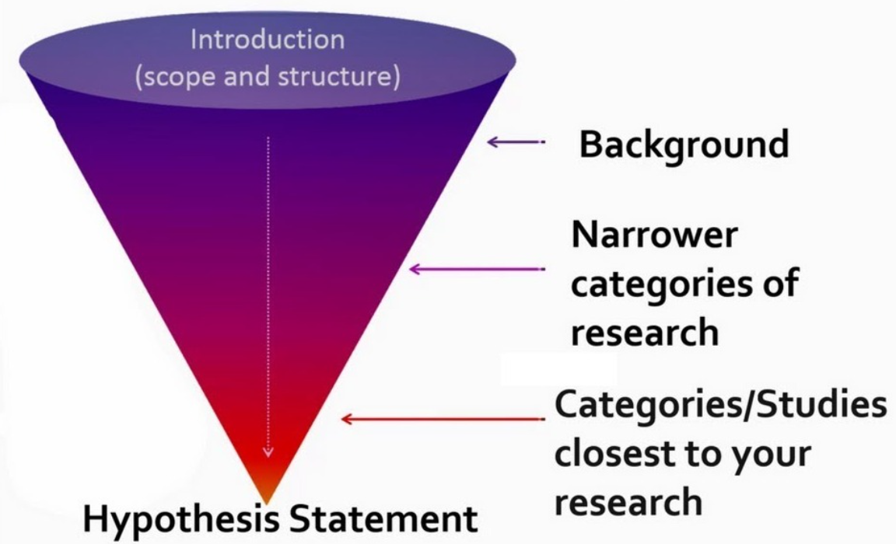

This chapter resembles the brief introduction about the most widely used field of study “Computer Vision”. Here talked about the various aspects and uses of computer vision, basic meaning and keywords like detection, Preprocessing, and discussed the roadmap to the report.

**1.2) Computer Vision**

Computer vision is an interdisciplinary scientific field that deals with how computers can gain high-level understanding from digital images or videos. It is most widely used field of artificial intelligence (AI) that enables computers and systems to derive meaningful information from digital images, videos and other visual inputs.

**3**

Different types of computer vision include image segmentation, object detection, facial recognition, edge detection[4], pattern detection, image classification, and feature matching.

Computer Vision itself is a big domain and is divided into

various subdomains like scene reconstruction, object detection, event detection, Disease Detection[4], object recognition, 3D pose estimation, learning, indexing, motion estimation, visual serving, 3D scene modeling, and image restoration.

**1.3) Application of Computer Vision**

It has various different application that too in various fields. Some of them are listed below:

* Disease Interpretation
* Screen Reader
* Intruder Detection
* Code and Character Reader
* Robotics
* Motion Analysis
* Image Restoration

There are many left to list as it is very wide topic and here in this project we have used one of the application i.e. Object Detection.

**1.4) Detection and Analysis**

Detection[4] is a computer technology related to computer vision and image processing that deals with detecting instances of semantic objects of a certain class (such as humans, buildings, or cars) in digital images and videos.

**4**

For Detection process in computer vision, there are various methods and each one have different level of accuracy according to their advancement level, like is some methods that is invented in very early stage, they give more cases of false detection[4] as compared to the advanced methods that had been discovered after that.

And here we have used the eye retina as an entity which we are detecting and analysing with different machine and deep learning algorithm and detecting the presence of DR in it.

**1.5) Roadmap to the report**

The structure of the report is as follows:

Chapter 1: It discusses about brief introduction of what computer vision is, what are there wide applications, some important keywords like detection[4] and analysis in computer vision, and finally roadmap of the report.

Chapter 2: It is based on the discussion of one of the domain of computer vision i.e. Diabetic Retinopathy and further is emphasize the detection of DR in pairs of retina images taken from fundus[2] camera and analysing the type of DR present**.**

Chapter 3: This chapter is based on frontend GUI application and detection of DR in image by selection of pairs of retina[3] images.

Chapter 4: It talks the accuracy of the deep learning[1] and machine learning algorithm that we have used in the detection process and analysis of the accuracy.

Chapter 5: At last, this chapter deals with a brief conclusion and further scope of this project.

**5**

**Chapter 2**

**Diabetic Retinopathy Interpretation**

**6**

**2.1) Diabetic Retinopathy Detection**

Firstly what is Diabetic Retinopathy? It is a Diabetic Eye Disease, a medical condition in which damage occurs to the retina[3] due to diabetes. It is leading cause of blindness in the various developed countries.

Detecting Diabetic Retinopathy means we have the pairs of Left and Right Retina image of the patient, and using that we used predefined machine and deep learning[1] algorithm to determine whether the patient is having Diabetic Retinopathy or not.

Also, if the patient is suffering from Diabetic Retinopathy, we have also implemented model to determine that the patient is suffering from which type of Diabetic Retinopathy medical disease.

It’s a diabetic complication that affects eyes, caused by damage to the blood vessels of the light sensitive tissue at the back of the eye(retina).[3]

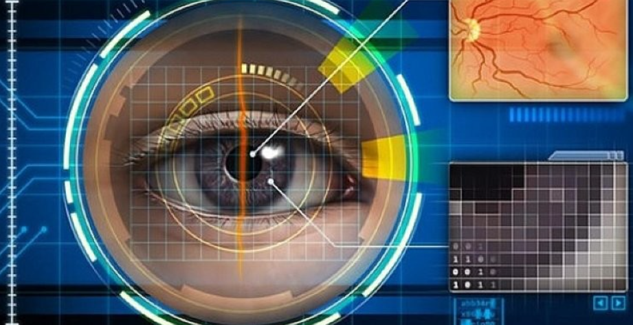

**7**

**2.2) Signs and Symptoms**

Diabetes is the most common symptom in all patient.

The patient having Diabetic Retinopathy medical disease mostly have the development of dark spots, blurred vision, empty areas in the vision.

The patient will having vision disorder and difficulty in perceiving different colours.

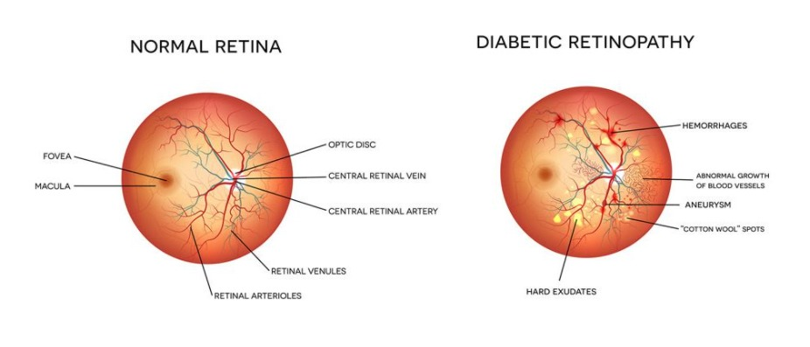

There are basically four stages of Diabetic Retinopathy:

- Mild Non-proliferative Retinopathy - Moderate Non-proliferative Retinopathy

- Severe Non-proliferative Retinopathy - Proliferative Diabetic Retinopathy

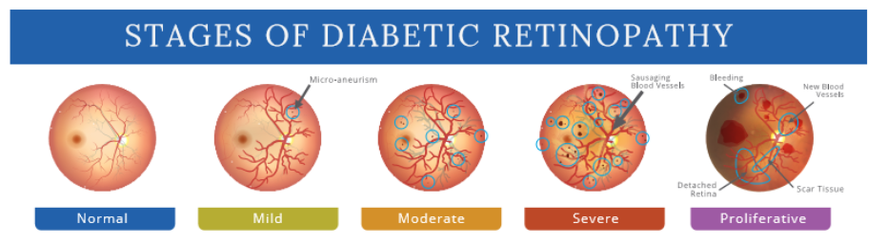

**8**

**2.3) Processing Algorithm**

First we read the data and cleaned the data. After this, we visualized the data using different graphs using matplotlib.plt library in python and analyzed the data.

Then we created the model using one of the most common algorithm i.e. SVC (Support Vector Classifier).

SVC is a non parametric clustering algorithm that does not make any assumption on the number of shape of the clusters in the data.

The Objective of Linear SVC is to fit the data we provide, returns a “best fit” hyperplane that divides or categorizes our data. From there, after getting the hyperplane, one can then feed some features to out classifier to see what the predicted[6] class is…

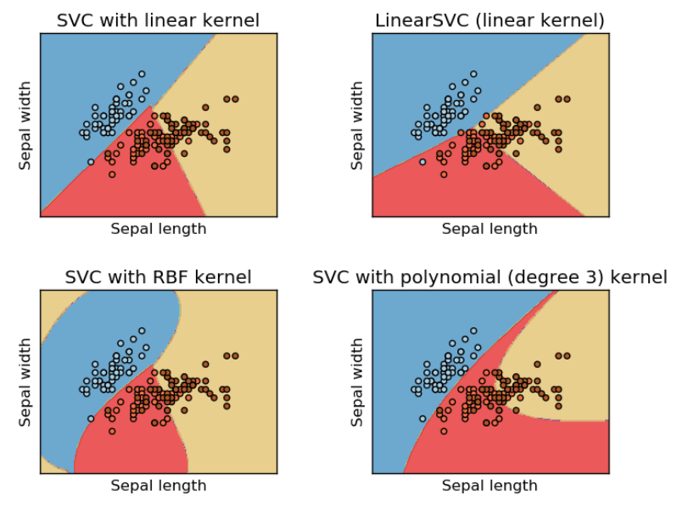

**9**

**2.4) Training and Testing Algorithm**

As we can see that we created the model and trained and analyzed the retina[3] images using SVC(Support Vector Classifier) algorithm.

Then we tested the trained model using KNN(K – Nearest Neighbours) algorithm. KNN algorithm is a simple, supervised machine learning algorithm that can be used to solve both classification and regression problems.

It’s easy to implement and understand, but has a major drawback of becoming significantly slow as the size of the data grows larger.

K-NN algorithm assumes the similarity between the new case/data and the available cases and put the new case into the category that is most similar to the available categories.

It is also a lazy learner algorithm because it does not learn from the training set immediately instead stores the dataset and at the time of classification, it performs the action on the dataset.

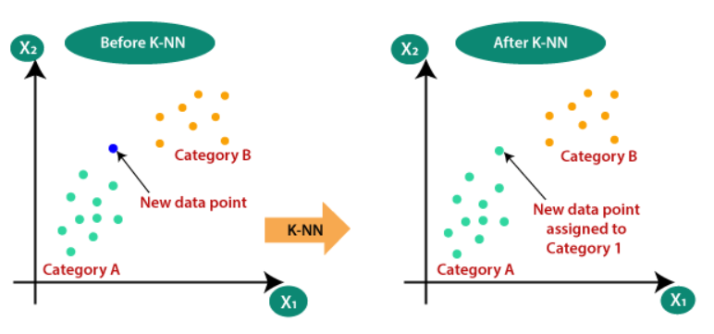

**10**

**2.5) Confusion Matrix**

In the field of machine learning and specifically the problem of statistical classification, a confusion matrix, also known as an error matrix, is a specific table layout that allows visualization of the performance of an algorithm, typically a supervised learning one.

Below is the confusion matrix for the detection of DR:

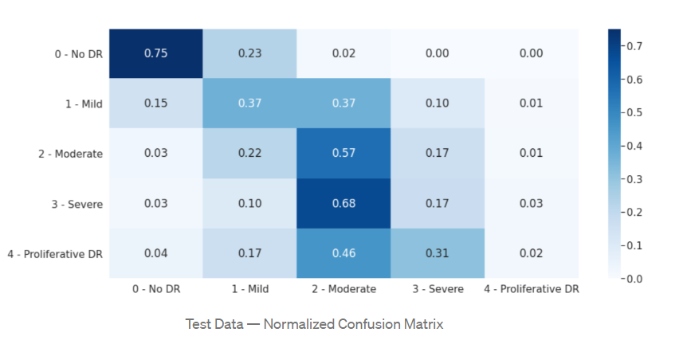

**11**

**Chapter 3**

**Detection**

**12**

**3.1) GUI and Detection**

After the model is being created, trained and tested, we created a frontend GUI kind of thing. Where user will be able asked to select the pair of left and right retina[3] image, and can check whether patient is having DR or not.

Also implemented the model to check if patient is suffering from only single eye i.e. either Left or Right eye.

In addition to it, user will also be able to figure out, that patient is suffering from which stage of DR is he/she is suffering.

Below are some screenshots of how GUI implementation looks like:

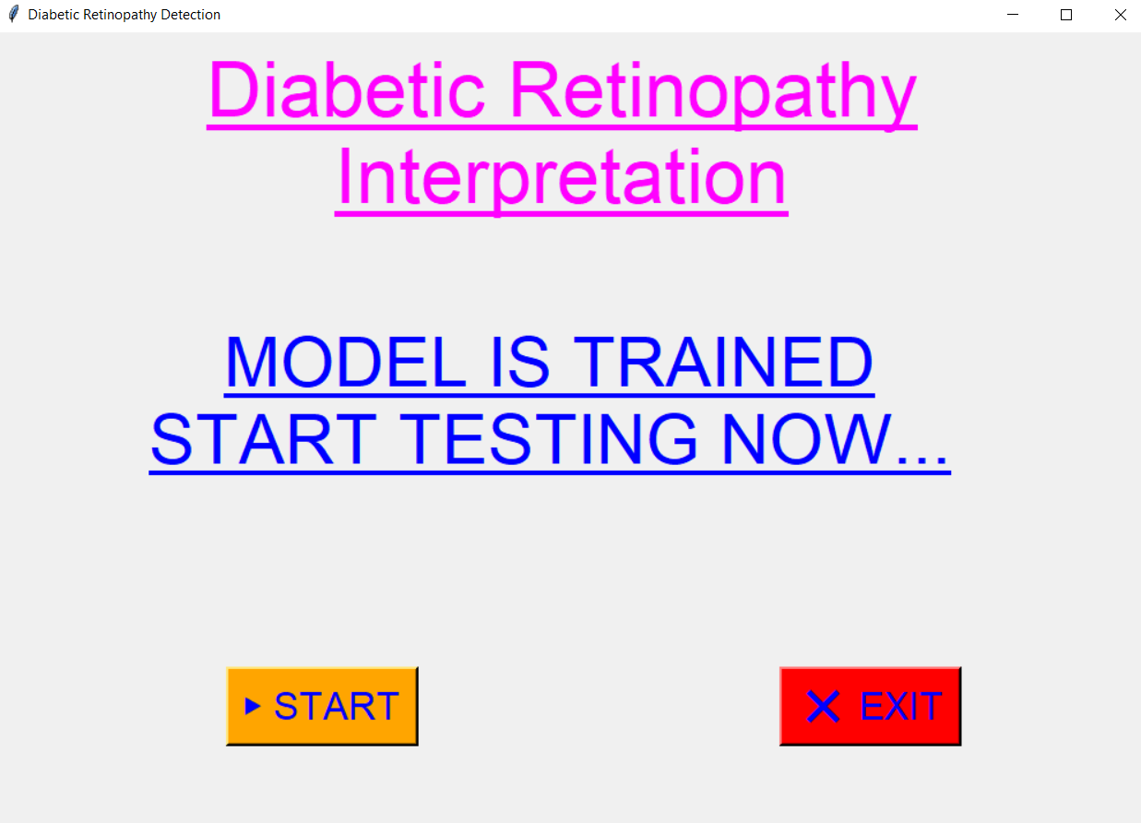

**13**

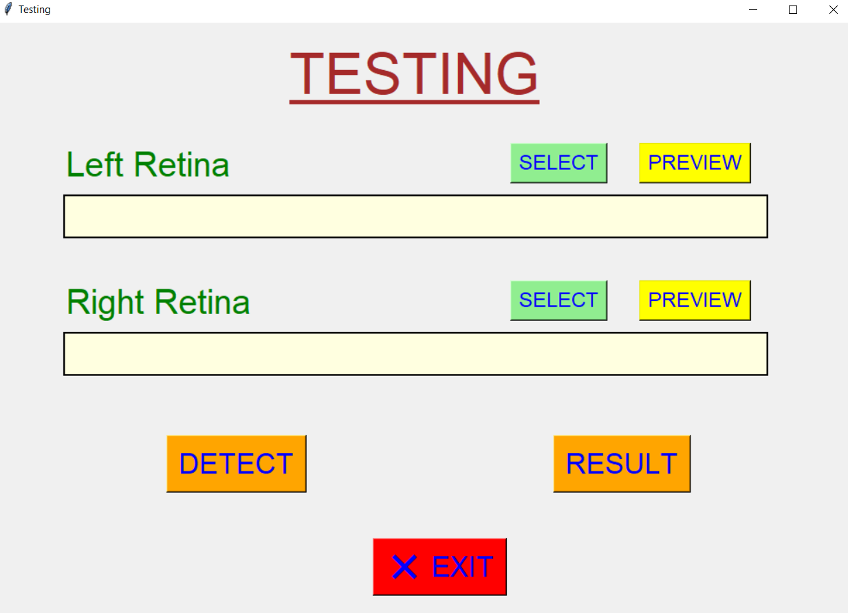

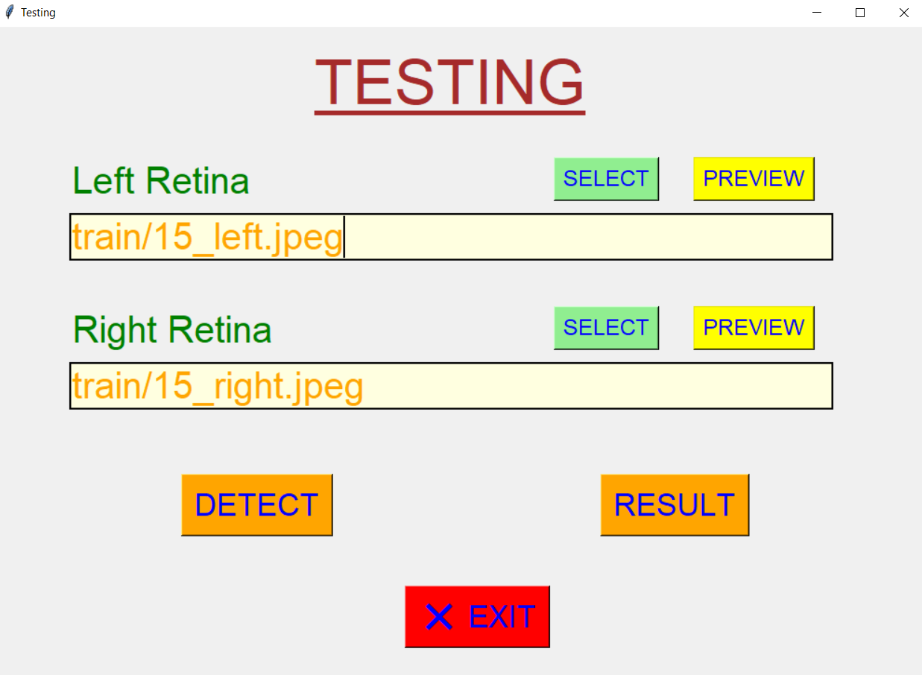

**14**

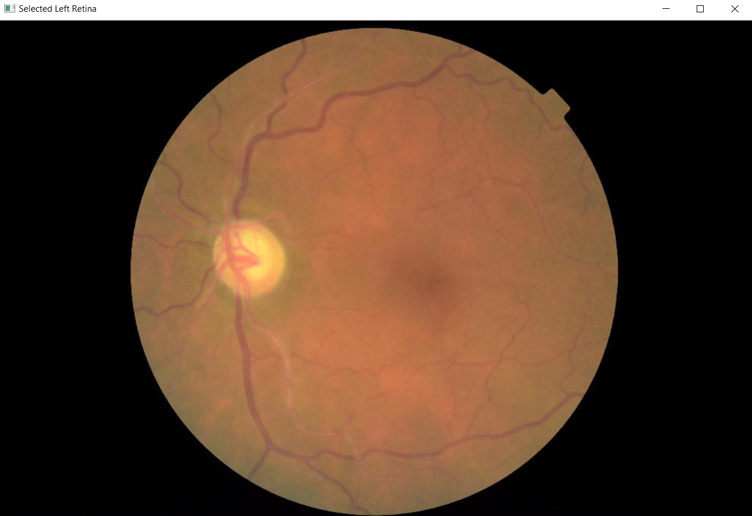

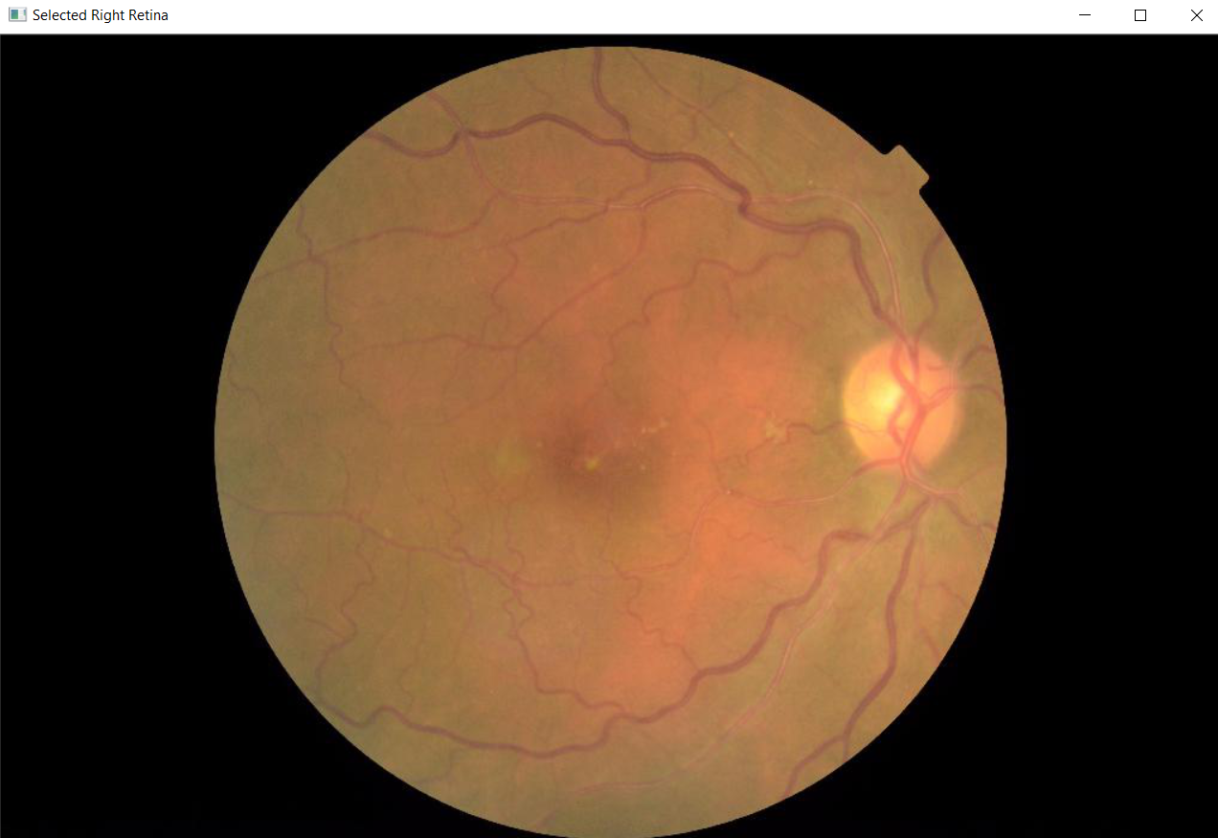

**15**

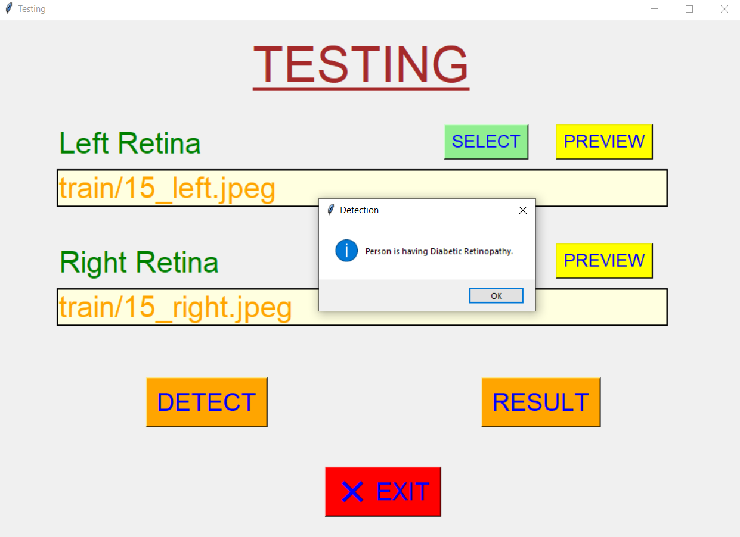

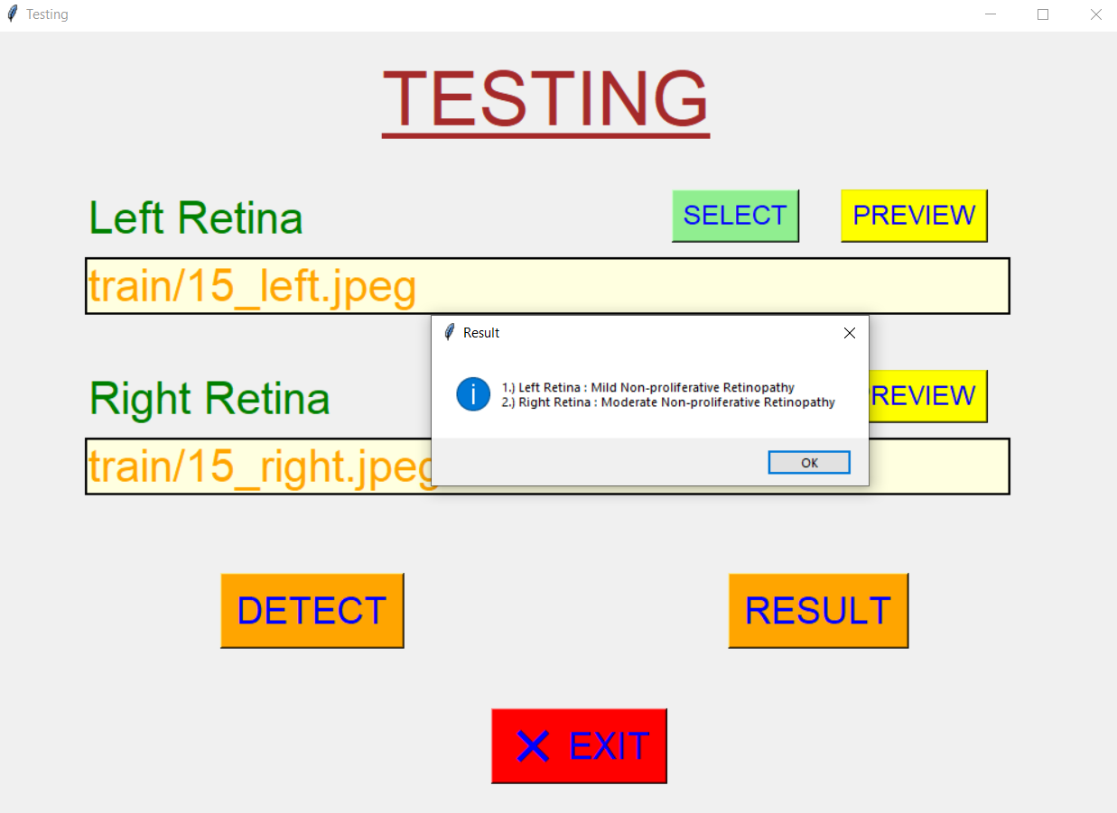

**16**

**Chapter 4**

**Accuracy**

**17**

**4.1) Accuracy**

The accuracy that we got after testing the trained model

Through SVC – 96.62 %

Through KNN – 94.38 %

The accuracy that we got after testing the testing model

Through SVC – 98.43 %

Through KNN – 93.17 %

**18**

**Chapter 5**

**Conclusion and Further Scope**

**19**

**5.1) Conclusion and Future Scopes**

Now coming to the future scope of this project or application, since in this we are taking any pair of retina[3] images and detecting whether DR is there or not. So some of the future scope can be :

* This can be used in various medical hospitals, for analysing the accuracy with the normal procedure of the DR detection[4].
* This can replace various mental jobs, and this can be done more efficiently with machines with this model as backend application.
* If this model is used on large scale, this will ultimately leads to better development.

**20**

**Research Papers**

1.) Alyoubi, Wejdan L., Wafaa M. Shalash, and Maysoon F. Abulkhair. "Diabetic retinopathy detection through deep learning[1] techniques: A review." *Informatics in Medicine Unlocked* 20 (2020): 100377.

2.) Oh, Kangrok, et al. "Early detection of diabetic retinopathy based on deep learning and ultra-wide-field fundus[2] images." *Scientific Reports* 11.1 (2021): 1-9.

3.) Verma, Kanika, Prakash Deep, and A. G. Ramakrishnan. "Detection and classification of diabetic retinopathy using retinal[3] images." *2011 Annual IEEE India Conference*. IEEE, 2011.

4.) Ayala, Angel, et al. "Diabetic Retinopathy Improved Detection[4] Using Deep Learning." *Applied Sciences* 11.24 (2021): 11970.

5.) Kaur, Prabhjot, Somsirsa Chatterjee, and Dilbag Singh. "Neural network technique for diabetic retinopathy detection." *Int J Eng Adv Technol (IJEAT)* 8.6 (2019): 440-445.

6.) Patil, Siddharekh S., and Kalpana Malpe. "Implementation of Diabetic Retinopathy Prediction[6] System using Data Mining." *2019 3rd International Conference on Computing Methodologies and Communication (ICCMC)*. IEEE, 2019.

**21**